# Software Engineering and Project Management Lab Experiment No: - 07 Aim: To Create Scrum Board for Scrum Master using JIRA Tool.

**Aim:** To Create Scrum Board for Scrum Master using JIRA Tool.

## Theory:

JIRA is a powerful project management tool widely used for implementing Agile methodologies such as Scrum. It enables teams to plan, track, and manage software development tasks through user stories, sprints, and boards. This experiment focuses on setting up a Scrum project in JIRA, creating user stories, managing the backlog, and configuring Scrum boards.

### Key Features of JIRA Scrum Projects:

* Template-driven Scrum project setup
* Interactive product backlog
* User story creation and prioritization
* Sprint planning and execution support
* Customizable Scrum boards
* Real-time collaboration and tracking

### Components Involved:

Component Description

Scrum Template Predefined format to set up an Agile Scrum project Product Backlog Collection of prioritized user stories and tasks

User Stories Functional requirements from the user's point of view Scrum Board Visual board to track tasks across sprints

Quick Filters Help in narrowing down and managing the board

### Demonstration (Theoretical Steps):

Step 1: Create a Scrum Project in JIRA

1. Log in to your JIRA account.
2. From the project templates, choose the Scrum template.
3. Once created, you'll land on the Product Backlog view — initially empty.

Step 2: Create User Stories or Tasks

* In JIRA, tasks, bugs, and stories are called issues.
* Use the Quick Create option to add user stories.
* Use the standard format for stories:

"As a {type of user}, I want {goal} so that I {receive benefit}".

Step 3: Prioritize User Stories in the Backlog Rearrange user stories by drag-and-drop or ranking.

The Product Owner typically prioritizes, and the team estimates effort. This order decides what gets pulled into the sprint first.

TSEC Batch:-T12 Name & Roll No:- Sarthak Hinge - 35

# Software Engineering and Project Management Lab Experiment No: - 07 Aim: To Create Scrum Board for Scrum Master using JIRA Tool.

Step 4: Create a Scrum Board

1. Go to Search > View all boards > Create board.
2. Select Scrum Board and link it to the existing project.
3. Configure columns and quick filters to match your workflow (e.g., To Do, In Progress, Done).

Step 5: Navigate Between Boards

* Use the Board Switcher from the left-hand menu under the project name.
* Easily switch between multiple boards if working on several projects.

### Use Case Example:

* Sprint-based development of a college project management portal.
* Bug tracking and resolution in an Agile web app project.
* Managing feature releases and feedback cycles for a mobile app.

**Implementation:**

TSEC Batch:-T12 Name & Roll No:- Sarthak Hinge - 35

# Software Engineering and Project Management Lab Experiment No: - 07 Aim: To Create Scrum Board for Scrum Master using JIRA Tool.

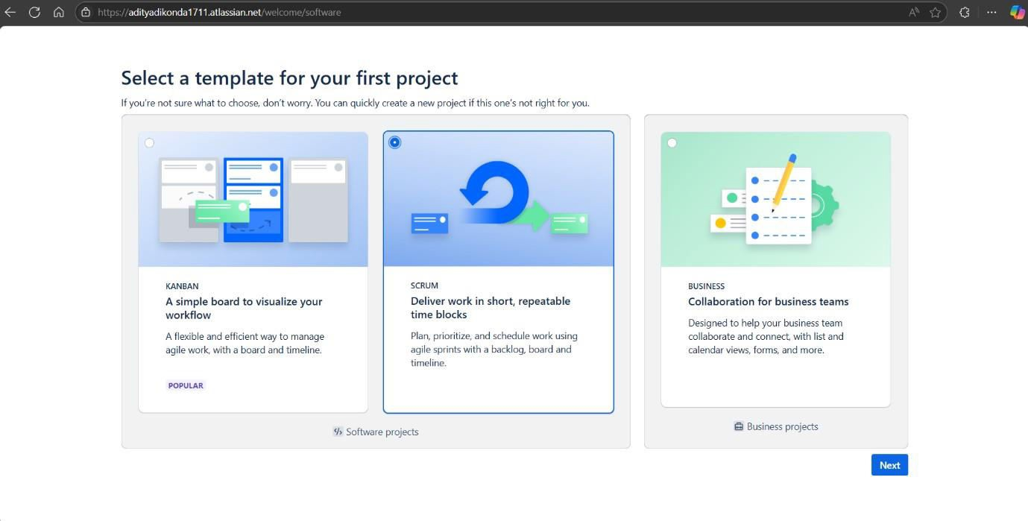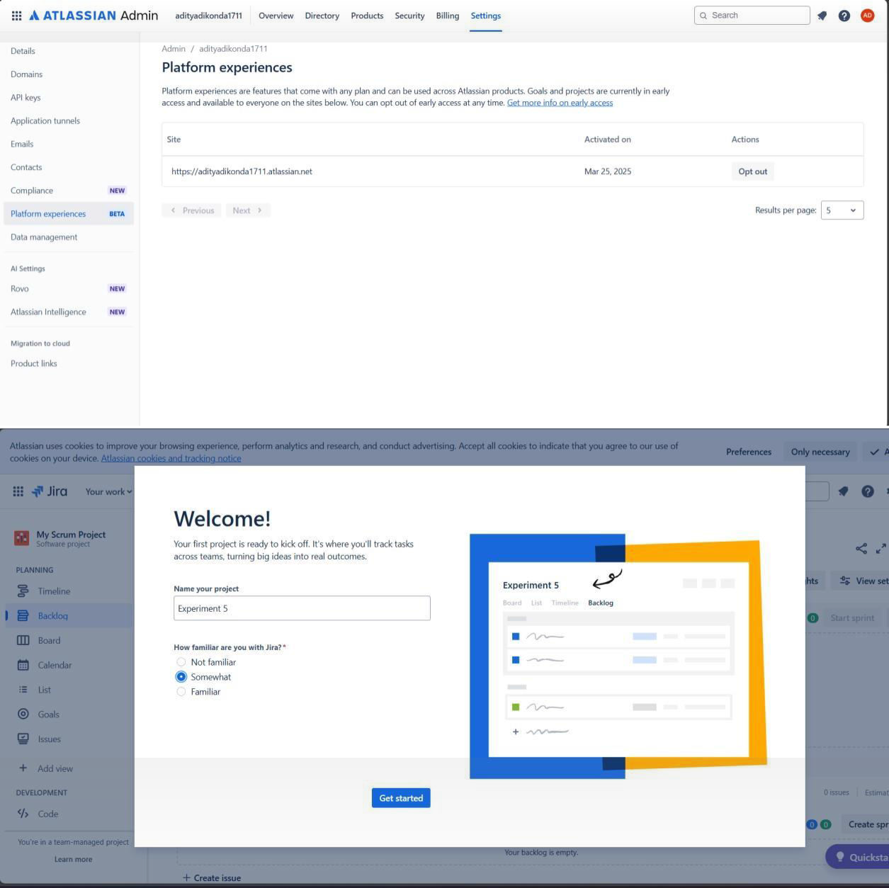

TSEC Batch:-T12 Name & Roll No:- Sarthak Hinge - 35

# Software Engineering and Project Management Lab Experiment No: - 07 Aim: To Create Scrum Board for Scrum Master using JIRA Tool.

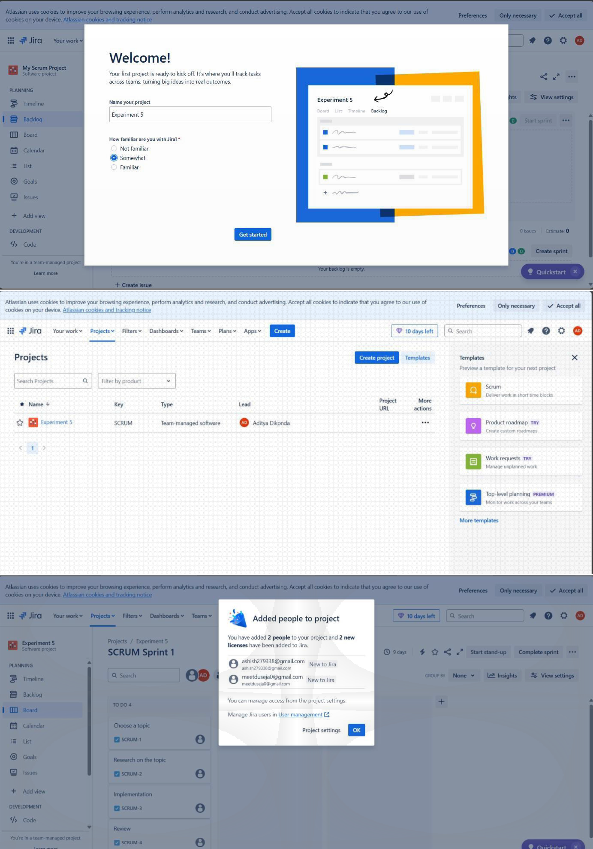

TSEC Batch:-T12 Name & Roll No:- Sarthak Hinge - 35

# Software Engineering and Project Management Lab Experiment No: - 07 Aim: To Create Scrum Board for Scrum Master using JIRA Tool.

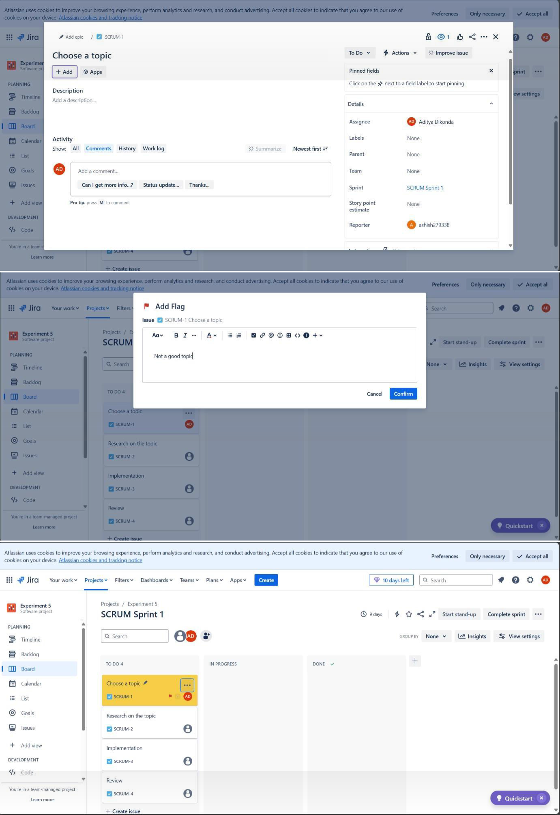

TSEC Batch:-T12 Name & Roll No:- Sarthak Hinge - 35

# Software Engineering and Project Management Lab Experiment No: - 07 Aim: To Create Scrum Board for Scrum Master using JIRA Tool.

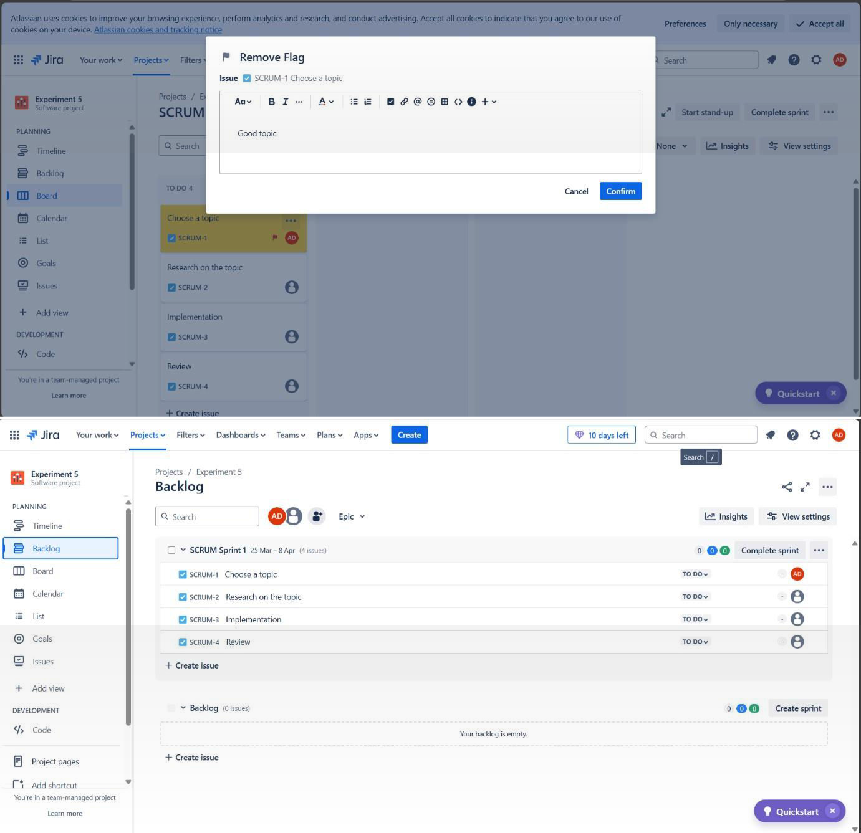

TSEC Batch:-T12 Name & Roll No:- Sarthak Hinge - 35

# Software Engineering and Project Management Lab Experiment No: - 07 Aim: To Create Scrum Board for Scrum Master using JIRA Tool.

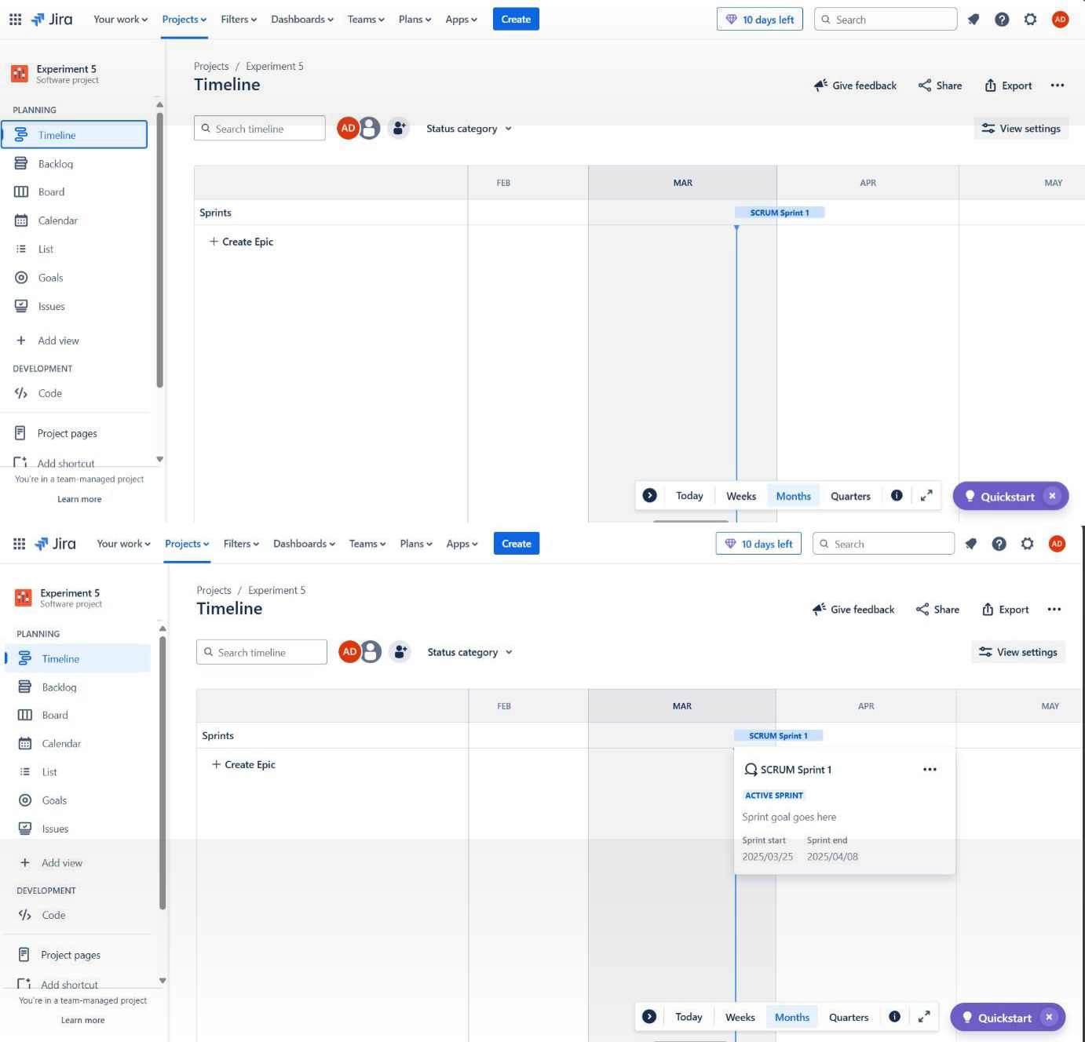

**Conclusion:** We have successfully created Scrum Board for Scrum Master using JIRA Tool.

**LO Mapping:** *LO is mapped*

TSEC Batch:-T12 Name & Roll No:- Sarthak Hinge - 35